Progress Report

- Report Summary

- Title of the project: Construction of Municipal Facilities/Community Centers in Rural Areas of the West Bank (#38745)
- Date of the approval: March 2004
- Project budget: US$1,620,000
- Scheme of the Project: Emergency Grant
- Period covered by the report: 1 January 2012 – 30 April 2012
- Names of UNDP Officer in charge, and Project Manager with their contact address:
Nader Atta, Program Analyst, UNDP/PAPP Jerusalem – 054-817-3956
- Name of PA counterpart:
Various Heads of Local Authorities

- Contents

  - Summary of the project
Component 1 - Construction of Community & Municipal Service Centers:

In order to improve the socio-economic well being of communities, this component provided for the construction of Community Service Centers in mostly rural communities of the West Bank. These centers have become a priority need for the communities for they provide an essential venue for services delivery. For implementation purposes, the Ministry of Local Government identified priority communities in the various districts of the West Bank.

As a result of the project, the local councils have been provided an address to govern their local needs. In addition, residents of the community served by the facility have been given access to such services as clinics, kindergartens, libraries, computer labs, and youth and women centers. In addition, the facilities encompass meeting rooms large enough to accommodate workshops, seminars, and other activities such as voting booths for the general elections. Through this component of the CAP I programme, it is planned that twenty-five (25) new service buildings will be constructed in various communities of the West Bank. This target has been fully met.

Results to date:

All 25 facilities have been constructed and completed in the West Bank. All facilities are operational and being utilized by the local communities. The facilities that have been constructed provide essential services to the communities they serve. Such services include kindergartens, health clinics, libraries, computer labs, and space for woman and youth centers. In addition, many facilities include offices for the local authorities who provide licensing, water, sewage, solid waste, and other services to their communities.

The 25 facilities were constructed in 10 of the 11 West Bank Governorates. Below is a breakdown of the distribution of the project sites by Governorate.

District: | Community Service Centers
Jericho | 1
Nablus | 2
Jenin | 3
Tulkarem | 3
Tubas | 2
Qalqiliya | 3
Ramallah | 3
Bethlehem | 2
Hebron/Dura | 3
Salfeet | 3
Total: | 25

  - Project component:

Component: | Budget: | Project site:
Construction of related Facilities of Large Community Centers: | $1,600,000 | Various locations in the West Bank.
Construction of related Facilities of Small Community Centers: | $720,000 | Various locations in the West Bank.

  - Project timeframe, schedule status, progress of activities, and tasks & measures

Indicated output | Activities | Timeframe |  |  |  |  |  |  |  | Schedule Status | Activities done in the reporting period | Remaining Work | Tasks & Measures
 |  | 2011 |  |  |  | 2012
 |  | 1Q | 2Q | 3Q | 4Q | 1Q | 2Q | 3Q | 4Q
Output 1: Essential service delivered. Short-term employment opportunities created. | Construction of a Small Community Service Building in the village of Talluza |  |  |  |  |  | x |  |  | All works completed | None | Drafting and submitting final report in May 2012. | Operationally & Financially Complete the project in UNDP. Prepare final report to be submitted in May 2012.

Project Completion Date: All works related to the project have been completed.

- Financial report

Budget items (according to the proposal) | A. Original budget (according to the proposal) | B. Revised budget  (if the original budget is revised) | C. Disbursement | D. Balance  (B-C) | E. Rate of disbursement (%) (C/B*100)
Site Engineer | $67,200 | $66,417 | $66,417 | $0 | 100%
Construction of Large Community Centers | $1,600,000 | $1,610,783 | $1,610,783 | $0 | 100%
Construction of Small Community Centers | $720,000 | $709,753 | $709,753 | $0 | 100%
Miscellaneous | $12,800 | $13,047 | $9,953 | $3,094 | 76%
Sub-total | $2,400,000 | $2,400,000 | $2,396,906 | $3,094 | 99%
GMS (8%) | $192,000 | $192,000 | $191,752 | $248 | 99%
Total: | $2,592,000 | $2,592,000 | $2,588,658 | $3,342 | 99%

- Any special notes or comments:

It is important to highlight that the financial figures in this report are temporary figures, and may be corrected at a later stage due to exchange rate fluctuations, realized gain/loss or any other possible corrections. UNDP/PAPP’s financial system operates in such a manner that the financial system closes in early December of each year and that final expenditure reports reflecting the disbursements and GMS of the previous year are only published in March of the following year.

The remaining funds under miscellaneous will be utilized to support a public relations tool for the overall CAP I programme.

- Pictures of project indicating progress of the project:

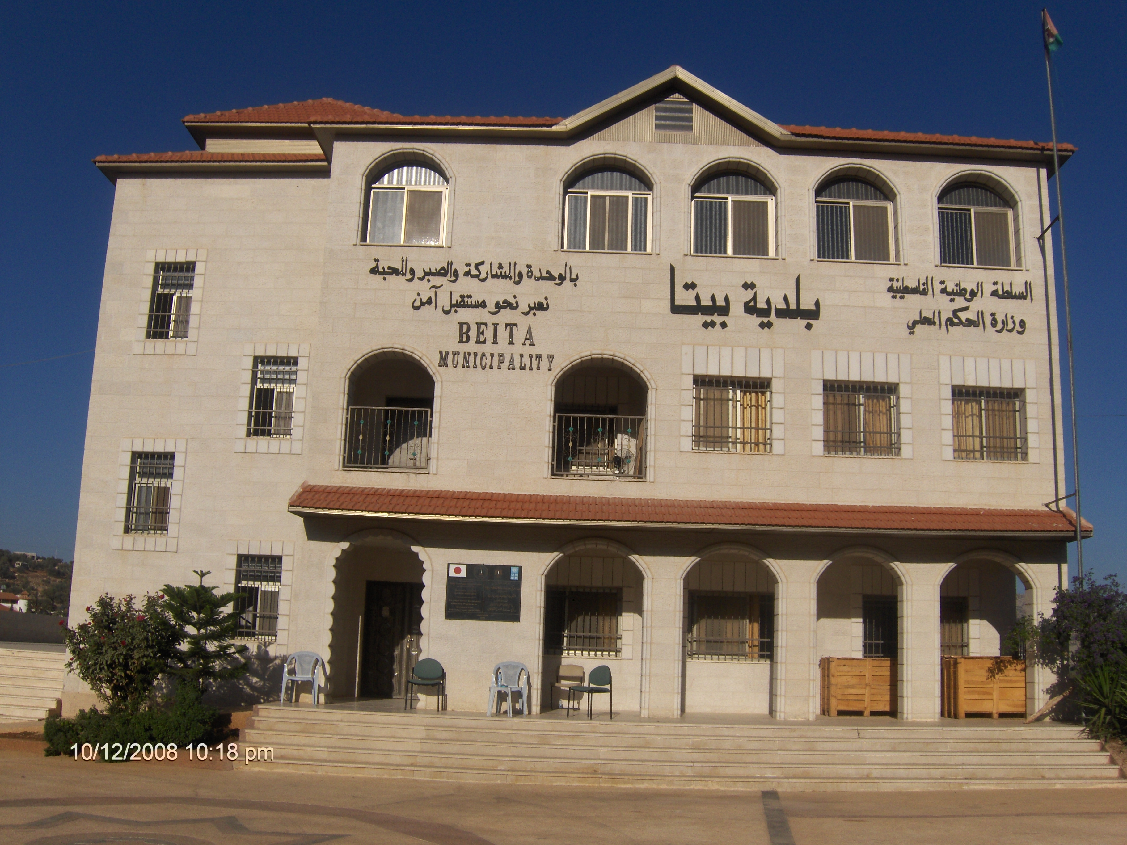  Beita Municipal Building – Nablus District | 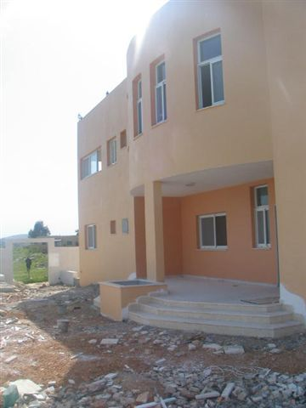  Nazlat Zeid Community Service Building –Jenin District
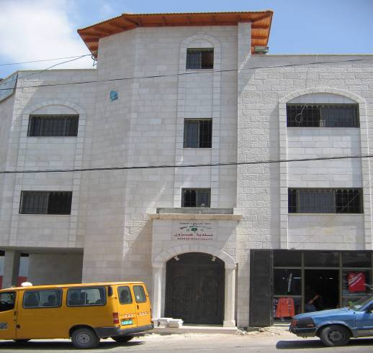  Azzoun Community Service Building – Qalqilya District | 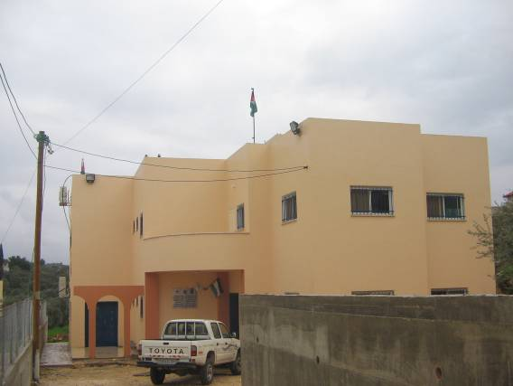  Kufr Thilth Community Service Building – Qalqiliya District
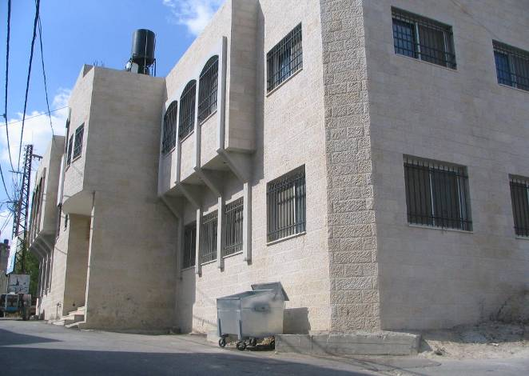  Sebastiya Community Service Building – Nablus District | 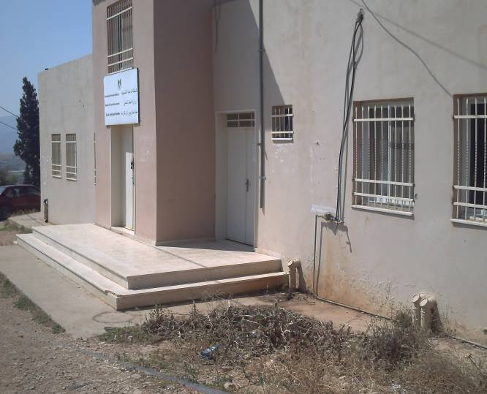  Ras El Fara’a Community Service Building – Tubas District
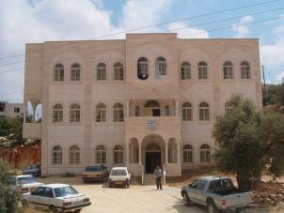  Beit Ulla Community Service Building – Hebron District | 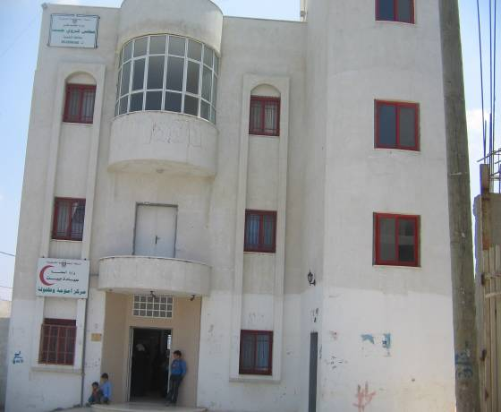  Jeet Community Service Building – Qalqiliya District

- Report authorization by UNDP/PAPP

Nader Atta, Program Analyst, Governance & Social Development Unit
Date of submission: 30 April 2012
Supervisor’s name and his/her signature: Abla Amawi, Team Leader

